Поиск примитивных полиномов

Таблица 2.1 – Примитивные полиномы

|  |  |  |  |  |  |  |
| --- | --- | --- | --- | --- | --- | --- |
| D1 | D2 | D3 | D4 | D5 | Итерации | Примитивный полином |
| 1 | 1 | 1 | 1 | 1 | 6 |  |
| 1 | 0 | 1 | 1 | 1 | 31 | **x5 ⊕ x4 ⊕ x3 ⊕ x2 ⊕ 1** |
| 1 | 1 | 0 | 1 | 1 | 31 | x5 ⊕ x4 ⊕ x3 ⊕ x1 ⊕ 1 |
| 1 | 0 | 0 | 1 | 1 | 14 |  |
| 1 | 1 | 1 | 0 | 1 | 31 | x5 ⊕ x4 ⊕ x2 ⊕ x1 ⊕ 1 |
| 1 | 0 | 1 | 0 | 1 | 15 |  |
| 1 | 1 | 0 | 0 | 1 | 8 |  |
| 1 | 0 | 0 | 0 | 1 | 21 |  |
| 1 | 1 | 1 | 1 | 0 | 31 | x5 ⊕ x3 ⊕ x2 ⊕ x1 ⊕ 1 |
| 1 | 0 | 1 | 1 | 0 | 12 |  |
| 1 | 1 | 0 | 1 | 0 | 15 |  |
| 1 | 0 | 0 | 1 | 0 | 31 | x5 ⊕ x3 ⊕ 1 |
| 1 | 1 | 1 | 0 | 0 | 14 |  |
| 1 | 0 | 1 | 0 | 0 | 31 | x5 ⊕ x2 ⊕ 1 |
| 1 | 1 | 0 | 0 | 0 | 21 |  |
| 1 | 0 | 0 | 0 | 0 | 1 |  |

Аналитическое деление полинома:

Анализируемая последовательность: 1111 1011 1011 1100.

Выбранный примитивный полином полином:

$$g\left(x\right)=x^{5}⊕x^{4}⊕x^{3}⊕x^{2}⊕1$$

Деление полинома:

|  |  |  |  |  |  |  |  |  |  |  |  |  |  |  |  |  |  |  |  |  |  |  |  |  |  |  |
| --- | --- | --- | --- | --- | --- | --- | --- | --- | --- | --- | --- | --- | --- | --- | --- | --- | --- | --- | --- | --- | --- | --- | --- | --- | --- | --- |
| 1 | 1 | 1 | 1 | 1 | 0 | 1 | 1 | 1 | 0 | 1 | 1 | 1 | 1 | 0 | 0 | 1 | 1 | 1 | 1 | 0 | 1 |  |  |  |  |  |
| 1 | 1 | 1 | 1 | 0 | 1 |  |  |  |  |  |  |  |  |  |  | 1 | 0 | 0 | 0 | 1 | 0 | 0 | 0 | 0 | 0 |  |
| 0 | 0 | 0 | 0 | 1 | 1 | 1 | 1 | 1 | 0 |  |  |  |  |  |  |  |  |  |  |  |  |  |  |  |  |  |
|  |  |  |  | 1 | 1 | 1 | 1 | 0 | 1 |  |  |  |  |  |  |  |  |  |  |  |  |  |  |  |  |  |
|  |  |  |  |  |  |  |  | 1 | 1 | 1 | 1 | 1 | 1 |  |  |  |  |  |  |  |  |  |  |  |  |  |
|  |  |  |  |  |  |  |  | 1 | 1 | 1 | 1 | 0 | 1 |  |  |  |  |  |  |  |  |  |  |  |  |  |
|  |  |  |  |  |  |  |  |  |  |  |  | 1 | 0 | 0 | 0 |  |  |  |  |  |  |  |  |  |  |  |

Остаток от деления: 01000.

Проверка результата деления с помощью учебной системы моделирования.

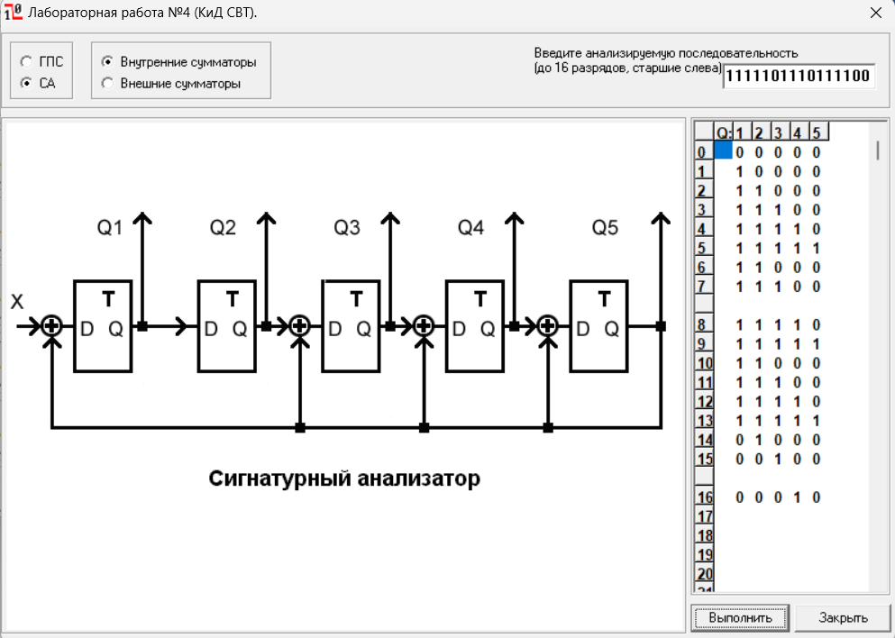

Видно, что 16-ая итерация имеет зеркальное остатку значение, что подтверждает правильность проведенных выше вычислений.

Для полинома

$$g\left(x\right)=x^{5}⊕x^{4}⊕x^{3}⊕x^{2}⊕1$$

составим обратный полином

$$g^{-1}\left(x\right)={x^{5}(x}^{-5}⊕x^{-4}⊕x^{-3}⊕x^{-2}⊕1)$$

$$g^{-1}(x)=1 ⊕x^{1}⊕x^{2}⊕x^{3}⊕x^{5}$$

*S’(x)* = 01100

*S’(x):*

|  |
| --- |
| 0 |
| 0 |
| 1 |
| 1 |
| 0 |

Матрица:

|  |  |  |  |  |
| --- | --- | --- | --- | --- |
| 1 | 0 | 0 | 0 | 0 |
| 1 | 1 | 0 | 0 | 0 |
| 1 | 1 | 1 | 0 | 0 |
| 1 | 1 | 1 | 1 | 0 |
| 0 | 1 | 1 | 1 | 1 |

Найдем *S(x) =*

|  |  |  |  |  |  |  |  |  |
| --- | --- | --- | --- | --- | --- | --- | --- | --- |
| 1*0 | + | 0*0 | + | 0*1 | + | 0*1 | + | 0*0 |
| 1*0 | + | 1*0 | + | 0*1 | + | 0*1 | + | 0*0 |
| 1*0 | + | 1*0 | + | 1*1 | + | 0*1 | + | 0*0 |
| 1*0 | + | 1*0 | + | 1*1 | + | 1*1 | + | 0*0 |
| 0*0 | + | 1*0 | + | 1*1 | + | 1*1 | + | 1*0 |

*S(x) =*

|  |
| --- |
| 0 |
| 1 |
| 0 |
| 0 |
| 0 |

*S(x) =* 01000

Проанализировав полученные результаты видно, что обе полученные сигнатуры совпадают, значит вычисления были проведены правильно.

Анализ сигнатур

Схема в собранном виде:

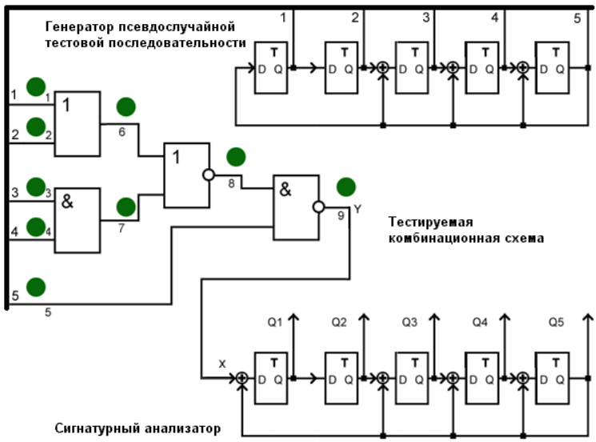

Карта эталонных сигнатур в полюсах 6, 7, 8 и 9

|  |  |  |  |  |  |  |  |  |  |  |  |  |  |  |  |  |  |  |  |  |  |  |  |  |  |  |  |  |  |  |  |  |  |  |  |  |  |  |  |  |  |  |  |  |  |  |  |  |  |  |  |  |  |  |  |  |  |  |  |
| --- | --- | --- | --- | --- | --- | --- | --- | --- | --- | --- | --- | --- | --- | --- | --- | --- | --- | --- | --- | --- | --- | --- | --- | --- | --- | --- | --- | --- | --- | --- | --- | --- | --- | --- | --- | --- | --- | --- | --- | --- | --- | --- | --- | --- | --- | --- | --- | --- | --- | --- | --- | --- | --- | --- | --- | --- | --- | --- | --- |
| **№** | ПСП | | | | | ЭС | | | | | | 6/0 | | | | | | 6/1 | | | | | | 7/0 | | | | | | 7/1 | | | | | | 8/0 | | | | | | 8/1 | | | | | | 9/0 | | | | | | 9/1 | | | | | |
| Q1 | Q2 | Q3 | Q4 | Q5 | **Y** | Q1 | Q2 | Q3 | Q4 | Q5 | **Y** | Q1 | Q2 | Q3 | Q4 | Q5 | **Y** | Q1 | Q2 | Q3 | Q4 | Q5 | **Y** | Q1 | Q2 | Q3 | Q4 | Q5 | **Y** | Q1 | Q2 | Q3 | Q4 | Q5 | **Y** | Q1 | Q2 | Q3 | Q4 | Q5 | **Y** | Q1 | Q2 | Q3 | Q4 | Q5 | **Y** | Q1 | Q2 | Q3 | Q4 | Q5 | **Y** | Q1 | Q2 | Q3 | Q4 | Q5 |
| **0** | 1 | 1 | 1 | 1 | 1 | **1** | 0 | 0 | 0 | 0 | 0 | **1** | 0 | 0 | 0 | 0 | 0 | **1** | 0 | 0 | 0 | 0 | 0 | **1** | 0 | 0 | 0 | 0 | 0 | **1** | 0 | 0 | 0 | 0 | 0 | **1** | 0 | 0 | 0 | 0 | 0 | **0** | 0 | 0 | 0 | 0 | 0 | **0** | 0 | 0 | 0 | 0 | 0 | **1** | 0 | 0 | 0 | 0 | 0 |
| **1** | 1 | 1 | 0 | 0 | 0 | **1** | 1 | 0 | 0 | 0 | 0 | **1** | 1 | 0 | 0 | 0 | 0 | **1** | 1 | 0 | 0 | 0 | 0 | **1** | 1 | 0 | 0 | 0 | 0 | **1** | 1 | 0 | 0 | 0 | 0 | **1** | 1 | 0 | 0 | 0 | 0 | **1** | 0 | 0 | 0 | 0 | 0 | **0** | 0 | 0 | 0 | 0 | 0 | **1** | 1 | 0 | 0 | 0 | 0 |
| **2** | 0 | 1 | 1 | 0 | 0 | **1** | 1 | 1 | 0 | 0 | 0 | **1** | 1 | 1 | 0 | 0 | 0 | **1** | 1 | 1 | 0 | 0 | 0 | **1** | 1 | 1 | 0 | 0 | 0 | **1** | 1 | 1 | 0 | 0 | 0 | **1** | 1 | 1 | 0 | 0 | 0 | **1** | 1 | 0 | 0 | 0 | 0 | **0** | 0 | 0 | 0 | 0 | 0 | **1** | 1 | 1 | 0 | 0 | 0 |
| **3** | 0 | 0 | 1 | 1 | 0 | **1** | 1 | 1 | 1 | 0 | 0 | **1** | 1 | 1 | 1 | 0 | 0 | **1** | 1 | 1 | 1 | 0 | 0 | **1** | 1 | 1 | 1 | 0 | 0 | **1** | 1 | 1 | 1 | 0 | 0 | **1** | 1 | 1 | 1 | 0 | 0 | **1** | 1 | 1 | 0 | 0 | 0 | **0** | 0 | 0 | 0 | 0 | 0 | **1** | 1 | 1 | 1 | 0 | 0 |
| **4** | 0 | 0 | 0 | 1 | 1 | **0** | 1 | 1 | 1 | 1 | 0 | **0** | 1 | 1 | 1 | 1 | 0 | **1** | 1 | 1 | 1 | 1 | 0 | **0** | 1 | 1 | 1 | 1 | 0 | **1** | 1 | 1 | 1 | 1 | 0 | **1** | 1 | 1 | 1 | 1 | 0 | **0** | 1 | 1 | 1 | 0 | 0 | **0** | 0 | 0 | 0 | 0 | 0 | **1** | 1 | 1 | 1 | 1 | 0 |
| **5** | 1 | 0 | 1 | 1 | 0 | **1** | 0 | 1 | 1 | 1 | 1 | **1** | 0 | 1 | 1 | 1 | 1 | **1** | 1 | 1 | 1 | 1 | 1 | **1** | 0 | 1 | 1 | 1 | 1 | **1** | 1 | 1 | 1 | 1 | 1 | **1** | 1 | 1 | 1 | 1 | 1 | **1** | 0 | 1 | 1 | 1 | 0 | **0** | 0 | 0 | 0 | 0 | 0 | **1** | 1 | 1 | 1 | 1 | 1 |
| **6** | 0 | 1 | 0 | 1 | 1 | **1** | 0 | 0 | 0 | 0 | 0 | **0** | 0 | 0 | 0 | 0 | 0 | **1** | 0 | 1 | 0 | 0 | 0 | **1** | 0 | 0 | 0 | 0 | 0 | **1** | 0 | 1 | 0 | 0 | 0 | **1** | 0 | 1 | 0 | 0 | 0 | **0** | 1 | 0 | 1 | 1 | 1 | **0** | 0 | 0 | 0 | 0 | 0 | **1** | 0 | 1 | 0 | 0 | 0 |
| **7** | 1 | 0 | 0 | 1 | 0 | **1** | 1 | 0 | 0 | 0 | 0 | **1** | 0 | 0 | 0 | 0 | 0 | **1** | 1 | 0 | 1 | 0 | 0 | **1** | 1 | 0 | 0 | 0 | 0 | **1** | 1 | 0 | 1 | 0 | 0 | **1** | 1 | 0 | 1 | 0 | 0 | **1** | 1 | 1 | 1 | 0 | 0 | **0** | 0 | 0 | 0 | 0 | 0 | **1** | 1 | 0 | 1 | 0 | 0 |
| **8** | 0 | 1 | 0 | 0 | 1 | **1** | 1 | 1 | 0 | 0 | 0 | **0** | 1 | 0 | 0 | 0 | 0 | **1** | 1 | 1 | 0 | 1 | 0 | **1** | 1 | 1 | 0 | 0 | 0 | **1** | 1 | 1 | 0 | 1 | 0 | **1** | 1 | 1 | 0 | 1 | 0 | **0** | 1 | 1 | 1 | 1 | 0 | **0** | 0 | 0 | 0 | 0 | 0 | **1** | 1 | 1 | 0 | 1 | 0 |
| **9** | 1 | 0 | 0 | 1 | 1 | **1** | 1 | 1 | 1 | 0 | 0 | **0** | 0 | 1 | 0 | 0 | 0 | **1** | 1 | 1 | 1 | 0 | 1 | **1** | 1 | 1 | 1 | 0 | 0 | **1** | 1 | 1 | 1 | 0 | 1 | **1** | 1 | 1 | 1 | 0 | 1 | **0** | 0 | 1 | 1 | 1 | 1 | **0** | 0 | 0 | 0 | 0 | 0 | **1** | 1 | 1 | 1 | 0 | 1 |
| **10** | 1 | 1 | 1 | 1 | 0 | **1** | 1 | 1 | 1 | 1 | 0 | **1** | 0 | 0 | 1 | 0 | 0 | **1** | 0 | 1 | 0 | 0 | 1 | **1** | 1 | 1 | 1 | 1 | 0 | **1** | 0 | 1 | 0 | 0 | 1 | **1** | 0 | 1 | 0 | 0 | 1 | **1** | 1 | 0 | 0 | 0 | 0 | **0** | 0 | 0 | 0 | 0 | 0 | **1** | 0 | 1 | 0 | 0 | 1 |
| **11** | 0 | 1 | 1 | 1 | 1 | **1** | 1 | 1 | 1 | 1 | 1 | **1** | 1 | 0 | 0 | 1 | 0 | **1** | 0 | 0 | 0 | 1 | 1 | **1** | 1 | 1 | 1 | 1 | 1 | **1** | 0 | 0 | 0 | 1 | 1 | **1** | 0 | 0 | 0 | 1 | 1 | **0** | 1 | 1 | 0 | 0 | 0 | **0** | 0 | 0 | 0 | 0 | 0 | **1** | 0 | 0 | 0 | 1 | 1 |
| **12** | 1 | 0 | 0 | 0 | 0 | **1** | 0 | 1 | 0 | 0 | 0 | **1** | 1 | 1 | 0 | 0 | 1 | **1** | 0 | 0 | 1 | 1 | 0 | **1** | 0 | 1 | 0 | 0 | 0 | **1** | 0 | 0 | 1 | 1 | 0 | **1** | 0 | 0 | 1 | 1 | 0 | **1** | 0 | 1 | 1 | 0 | 0 | **0** | 0 | 0 | 0 | 0 | 0 | **1** | 0 | 0 | 1 | 1 | 0 |
| **13** | 0 | 1 | 0 | 0 | 0 | **1** | 1 | 0 | 1 | 0 | 0 | **1** | 0 | 1 | 0 | 1 | 1 | **1** | 1 | 0 | 0 | 1 | 1 | **1** | 1 | 0 | 1 | 0 | 0 | **1** | 1 | 0 | 0 | 1 | 1 | **1** | 1 | 0 | 0 | 1 | 1 | **1** | 1 | 0 | 1 | 1 | 0 | **0** | 0 | 0 | 0 | 0 | 0 | **1** | 1 | 0 | 0 | 1 | 1 |
| **14** | 0 | 0 | 1 | 0 | 0 | **1** | 1 | 1 | 0 | 1 | 0 | **1** | 0 | 0 | 0 | 1 | 0 | **1** | 0 | 1 | 1 | 1 | 0 | **1** | 1 | 1 | 0 | 1 | 0 | **1** | 0 | 1 | 1 | 1 | 0 | **1** | 0 | 1 | 1 | 1 | 0 | **1** | 1 | 1 | 0 | 1 | 1 | **0** | 0 | 0 | 0 | 0 | 0 | **1** | 0 | 1 | 1 | 1 | 0 |
| **15** | 0 | 0 | 0 | 1 | 0 | **1** | 1 | 1 | 1 | 0 | 1 | **1** | 1 | 0 | 0 | 0 | 1 | **1** | 1 | 0 | 1 | 1 | 1 | **1** | 1 | 1 | 1 | 0 | 1 | **1** | 1 | 0 | 1 | 1 | 1 | **1** | 1 | 0 | 1 | 1 | 1 | **1** | 0 | 1 | 0 | 1 | 0 | **0** | 0 | 0 | 0 | 0 | 0 | **1** | 1 | 0 | 1 | 1 | 1 |
| **16** | 0 | 0 | 0 | 0 | 1 | **0** | 0 | 1 | 0 | 0 | 1 | **0** | 0 | 1 | 1 | 1 | 1 | **1** | 0 | 1 | 1 | 0 | 0 | **0** | 0 | 1 | 0 | 0 | 1 | **1** | 0 | 1 | 1 | 0 | 0 | **1** | 0 | 1 | 1 | 0 | 0 | **0** | 1 | 0 | 1 | 0 | 1 | **0** | 0 | 0 | 0 | 0 | 0 | **1** | 0 | 1 | 1 | 0 | 0 |
| **17** | 1 | 0 | 1 | 1 | 1 | **1** | 1 | 0 | 0 | 1 | 1 | **1** | 1 | 0 | 0 | 0 | 0 | **1** | 1 | 0 | 1 | 1 | 0 | **1** | 1 | 0 | 0 | 1 | 1 | **1** | 1 | 0 | 1 | 1 | 0 | **1** | 1 | 0 | 1 | 1 | 0 | **0** | 1 | 1 | 1 | 0 | 1 | **0** | 0 | 0 | 0 | 0 | 0 | **1** | 1 | 0 | 1 | 1 | 0 |
| **18** | 1 | 1 | 1 | 0 | 0 | **1** | 0 | 1 | 1 | 1 | 0 | **1** | 1 | 1 | 0 | 0 | 0 | **1** | 1 | 1 | 0 | 1 | 1 | **1** | 0 | 1 | 1 | 1 | 0 | **1** | 1 | 1 | 0 | 1 | 1 | **1** | 1 | 1 | 0 | 1 | 1 | **1** | 1 | 1 | 0 | 0 | 1 | **0** | 0 | 0 | 0 | 0 | 0 | **1** | 1 | 1 | 0 | 1 | 1 |
| **19** | 0 | 1 | 1 | 1 | 0 | **1** | 1 | 0 | 1 | 1 | 1 | **1** | 1 | 1 | 1 | 0 | 0 | **1** | 0 | 1 | 0 | 1 | 0 | **1** | 1 | 0 | 1 | 1 | 1 | **1** | 0 | 1 | 0 | 1 | 0 | **1** | 0 | 1 | 0 | 1 | 0 | **1** | 0 | 1 | 0 | 1 | 1 | **0** | 0 | 0 | 0 | 0 | 0 | **1** | 0 | 1 | 0 | 1 | 0 |
| **20** | 0 | 0 | 1 | 1 | 1 | **1** | 0 | 1 | 1 | 0 | 0 | **1** | 1 | 1 | 1 | 1 | 0 | **1** | 1 | 0 | 1 | 0 | 1 | **0** | 0 | 1 | 1 | 0 | 0 | **1** | 1 | 0 | 1 | 0 | 1 | **1** | 1 | 0 | 1 | 0 | 1 | **0** | 0 | 0 | 0 | 1 | 0 | **0** | 0 | 0 | 0 | 0 | 0 | **1** | 1 | 0 | 1 | 0 | 1 |
| **21** | 1 | 0 | 1 | 0 | 0 | **1** | 1 | 0 | 1 | 1 | 0 | **1** | 1 | 1 | 1 | 1 | 1 | **1** | 0 | 1 | 1 | 0 | 1 | **1** | 0 | 0 | 1 | 1 | 0 | **1** | 0 | 1 | 1 | 0 | 1 | **1** | 0 | 1 | 1 | 0 | 1 | **1** | 0 | 0 | 0 | 0 | 1 | **0** | 0 | 0 | 0 | 0 | 0 | **1** | 0 | 1 | 1 | 0 | 1 |
| **22** | 0 | 1 | 0 | 1 | 0 | **1** | 1 | 1 | 0 | 1 | 1 | **1** | 0 | 1 | 0 | 0 | 0 | **1** | 0 | 0 | 0 | 0 | 1 | **1** | 1 | 0 | 0 | 1 | 1 | **1** | 0 | 0 | 0 | 0 | 1 | **1** | 0 | 0 | 0 | 0 | 1 | **1** | 0 | 0 | 1 | 1 | 1 | **0** | 0 | 0 | 0 | 0 | 0 | **1** | 0 | 0 | 0 | 0 | 1 |
| **23** | 0 | 0 | 1 | 0 | 1 | **0** | 0 | 1 | 0 | 1 | 0 | **0** | 1 | 0 | 1 | 0 | 0 | **1** | 0 | 0 | 1 | 1 | 1 | **0** | 0 | 1 | 1 | 1 | 0 | **1** | 0 | 0 | 1 | 1 | 1 | **1** | 0 | 0 | 1 | 1 | 1 | **0** | 0 | 0 | 1 | 0 | 0 | **0** | 0 | 0 | 0 | 0 | 0 | **1** | 0 | 0 | 1 | 1 | 1 |
| **24** | 1 | 0 | 1 | 0 | 1 | **1** | 0 | 0 | 1 | 0 | 1 | **0** | 0 | 1 | 0 | 1 | 0 | **1** | 0 | 0 | 1 | 0 | 0 | **1** | 0 | 0 | 1 | 1 | 1 | **1** | 0 | 0 | 1 | 0 | 0 | **1** | 0 | 0 | 1 | 0 | 0 | **0** | 0 | 0 | 0 | 1 | 0 | **0** | 0 | 0 | 0 | 0 | 0 | **1** | 0 | 0 | 1 | 0 | 0 |
| **25** | 1 | 1 | 1 | 0 | 1 | **1** | 0 | 0 | 1 | 0 | 1 | **0** | 0 | 0 | 1 | 0 | 1 | **1** | 1 | 0 | 0 | 1 | 0 | **1** | 0 | 0 | 1 | 0 | 0 | **1** | 1 | 0 | 0 | 1 | 0 | **1** | 1 | 0 | 0 | 1 | 0 | **0** | 0 | 0 | 0 | 0 | 1 | **0** | 0 | 0 | 0 | 0 | 0 | **1** | 1 | 0 | 0 | 1 | 0 |
| **26** | 1 | 1 | 0 | 0 | 1 | **1** | 0 | 0 | 1 | 0 | 1 | **0** | 1 | 0 | 1 | 0 | 1 | **1** | 1 | 1 | 0 | 0 | 1 | **1** | 1 | 0 | 0 | 1 | 0 | **1** | 1 | 1 | 0 | 0 | 1 | **1** | 1 | 1 | 0 | 0 | 1 | **0** | 1 | 0 | 1 | 1 | 1 | **0** | 0 | 0 | 0 | 0 | 0 | **1** | 1 | 1 | 0 | 0 | 1 |
| **27** | 1 | 1 | 0 | 1 | 1 | **1** | 0 | 0 | 1 | 0 | 1 | **0** | 1 | 1 | 1 | 0 | 1 | **1** | 0 | 1 | 0 | 1 | 1 | **1** | 1 | 1 | 0 | 0 | 1 | **1** | 0 | 1 | 0 | 1 | 1 | **1** | 0 | 1 | 0 | 1 | 1 | **0** | 1 | 1 | 1 | 0 | 0 | **0** | 0 | 0 | 0 | 0 | 0 | **1** | 0 | 1 | 0 | 1 | 1 |
| **28** | 1 | 1 | 0 | 1 | 0 | **1** | 0 | 0 | 1 | 0 | 1 | **1** | 1 | 1 | 0 | 0 | 1 | **1** | 0 | 0 | 0 | 1 | 0 | **1** | 0 | 1 | 0 | 1 | 1 | **1** | 0 | 0 | 0 | 1 | 0 | **1** | 0 | 0 | 0 | 1 | 0 | **1** | 0 | 1 | 1 | 1 | 0 | **0** | 0 | 0 | 0 | 0 | 0 | **1** | 0 | 0 | 0 | 1 | 0 |
| **29** | 0 | 1 | 1 | 0 | 1 | **1** | 0 | 0 | 1 | 0 | 1 | **0** | 0 | 1 | 0 | 1 | 1 | **1** | 1 | 0 | 0 | 0 | 1 | **1** | 0 | 0 | 0 | 1 | 0 | **1** | 1 | 0 | 0 | 0 | 1 | **1** | 1 | 0 | 0 | 0 | 1 | **0** | 1 | 0 | 1 | 1 | 1 | **0** | 0 | 0 | 0 | 0 | 0 | **1** | 1 | 0 | 0 | 0 | 1 |
| **30** | 1 | 0 | 0 | 0 | 1 | **1** | 0 | 0 | 1 | 0 | 1 | **0** | 1 | 0 | 0 | 1 | 0 | **1** | 0 | 1 | 1 | 1 | 1 | **1** | 1 | 0 | 0 | 0 | 1 | **1** | 0 | 1 | 1 | 1 | 1 | **1** | 0 | 1 | 1 | 1 | 1 | **0** | 1 | 1 | 1 | 0 | 0 | **0** | 0 | 0 | 0 | 0 | 0 | **1** | 0 | 1 | 1 | 1 | 1 |
| **31** | 1 | 1 | 1 | 1 | 1 | **1** | 0 | 0 | 1 | 0 | 1 | **1** | 0 | 1 | 0 | 0 | 1 | **1** | 0 | 0 | 0 | 0 | 0 | **1** | 0 | 1 | 1 | 1 | 1 | **1** | 0 | 0 | 0 | 0 | 0 | **1** | 0 | 0 | 0 | 0 | 0 | **0** | 0 | 1 | 1 | 1 | 0 | **0** | 0 | 0 | 0 | 0 | 0 | **1** | 0 | 0 | 0 | 0 | 0 |

Первым набором, для которого сигнатуры при всех неисправностях начинают отличатся от эталонных, является набор № 21.

|  |  |  |  |  |  |
| --- | --- | --- | --- | --- | --- |
| Неисправность | Q1 | Q2 | Q3 | Q4 | Q5 |
| 6/0 | 0 | 0 | 0 | 0 | 0 |
| 6/1 | 1 | 1 | 1 | 1 | 1 |
| 7/0 | 0 | 0 | 1 | 1 | 0 |
| 7/1 | 1 | 1 | 1 | 1 | 1 |
| 8/0 | 1 | 1 | 1 | 1 | 1 |
| 8/1 | 0 | 0 | 0 | 0 | 0 |
| 9/0 | 0 | 0 | 0 | 0 | 0 |
| 9/1 | 1 | 1 | 1 | 1 | 1 |

Неисправности 6/0, 8/1, 9/0 и 6/1, 7/1, 8/0, 9/1 соответственно имеют одинаковые сигнатуры, следовательно определить, какая именно из этих неисправностей имеется, невозможно.